**Lab 8: UDP**

University of Windsor

Department of Electrical and Computer Engineering

ELEC 8560 – Computer Networks

Semester: Fall 2023

**Student Name**: Amey Mahendra Thakur

**Student number**: 110107589

**Answers:**

1. The first UDP segment's application-layer payload is of the **UDP** type. The UDP header comprises **four** elements:
   1. **Source Port,**
   2. **Destination Port,**
   3. **Length, and**
   4. **Checksum.**

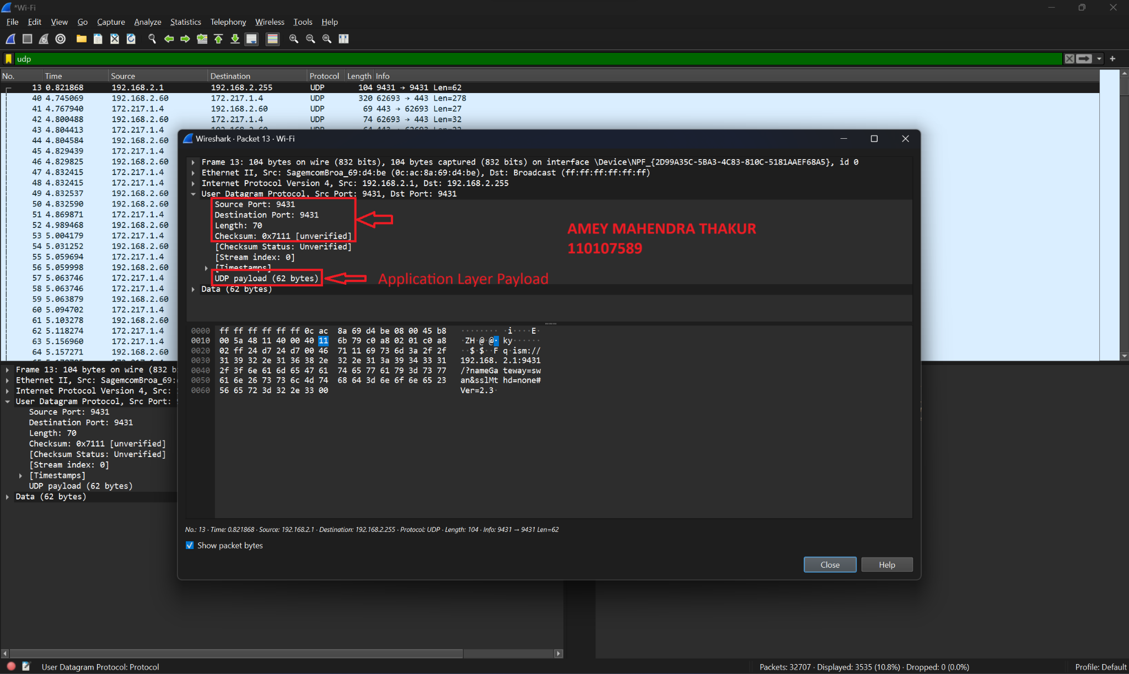

1. The UDP header consistently measures 8 bytes in total, with each of its four fields being 2 bytes in size.

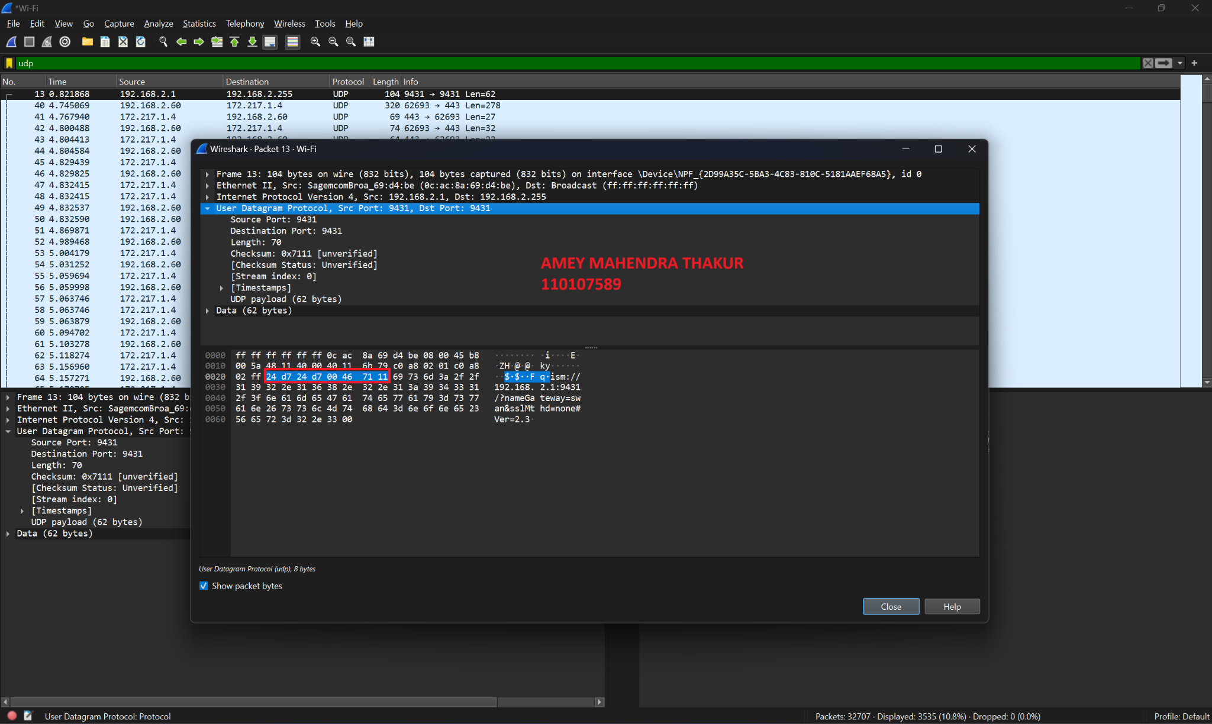

1. The Length field in a UDP segment indicates the total byte count, including both header and data. For the selected packet, the **UDP payload is 62 bytes,** derived from **subtracting 8 bytes (header size) from the total length of 70 bytes.**

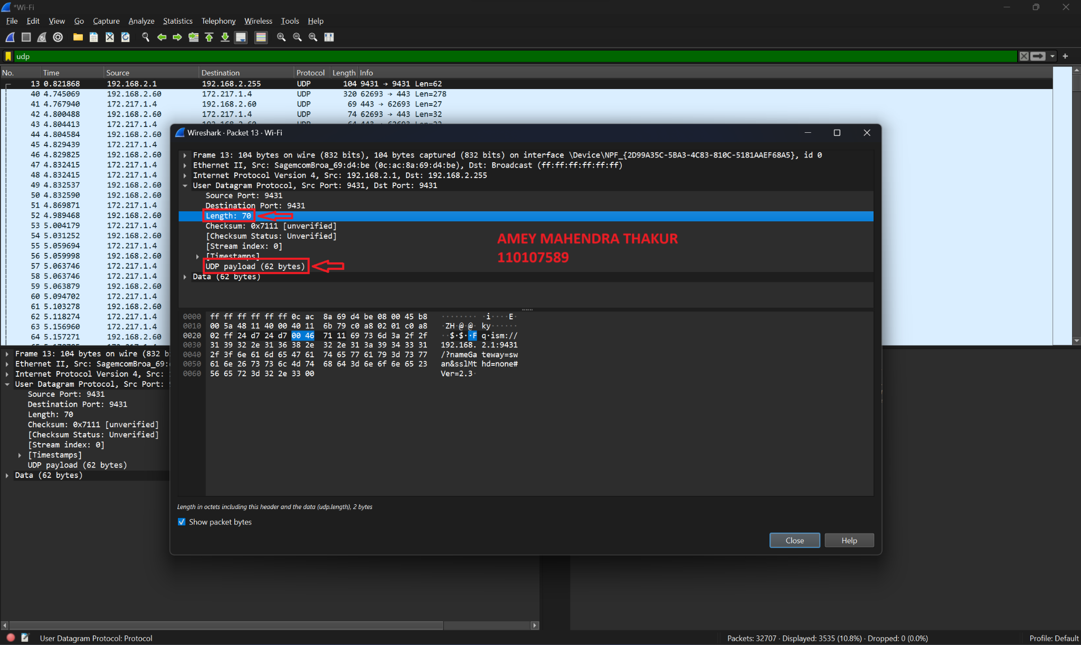

1. The maximum number of bytes that can be included in a UDP payload is (2^16 – 1) bytes plus the header bytes. This gives **65535 bytes – 8 bytes = 65527 bytes.**
2. The largest possible source port number is (2^16 – 1) = 65535
3. UDP's IP protocol number is **17** in decimal form, which corresponds to **0x11 in hexadecimal.**

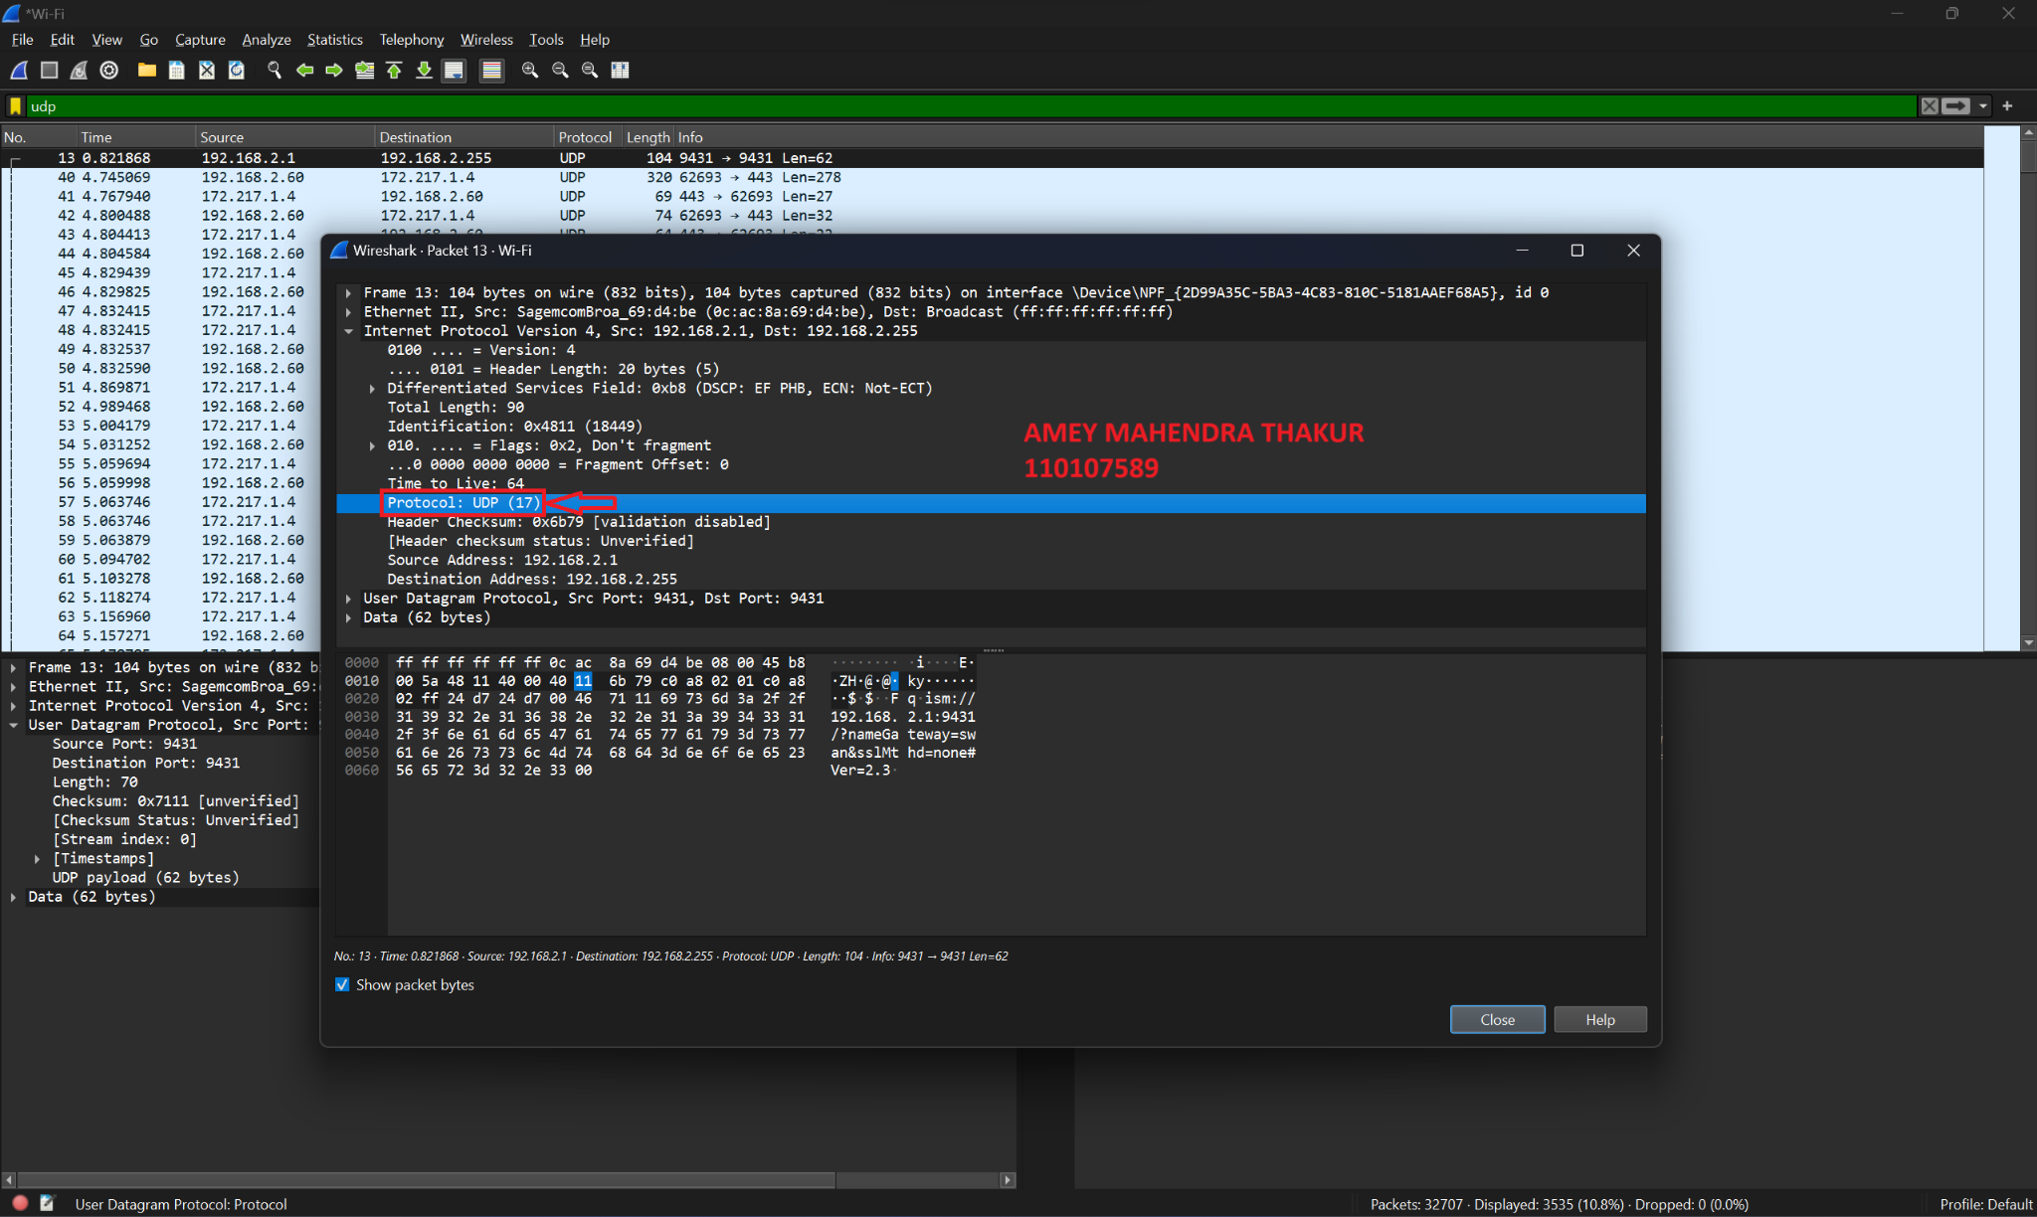

1. The source port in the UDP packet sent by the host matches the destination port in the received reply packet, and the destination port in the sent packet aligns with the source port in the reply.

